**Purpose of the chapter**

1. Define a project
2. Define project success
3. Project constraints
4. Project management expertise
5. The project environment
6. Project management knowledge and skills

**Define a project**

1. Unique product or service
2. Time-limited
3. The project ends when the objectives are achieved or abandoned

**How can you tell that an activity is unique?**

1. Completely new product or service
2. Creation of a new process
3. Product or service new to this group of people

**Time-limited**

1. May have a start and end date
2. May be measured as “will be complete when a particular objective is achieved”
3. If it simply continues forever or to an unspecified end date it is probably an ongoing business activity

**Can tell when it is done**

1. Objective is achieved
2. The time limit is reached
3. Objective is abandoned

**Project Success**

1. Traditionally: on time, within budget and delivers the promised scope
2. More effective measure: satisfied customer

**Group work**

1. In small groups, try to identify the LARGEST project each of you has been involved with.
2. You do not have to have been the project manager—if not, what was your role? (team member, volunteer, purchaser, ??)
3. With the group, make it clear how the project you have identified meets the criteria:
   1. Unique
   2. Temporary

**Project constraints**

1. Cost
2. Scope
3. Quality
4. Risk
5. 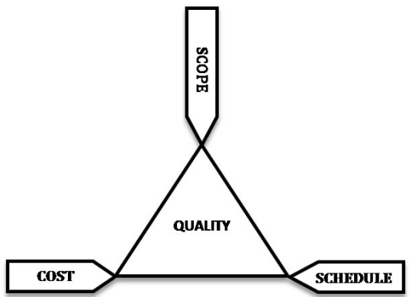Resources
6. Time

**Triple constraint**

All the constraints can be grouped into these three:

**Project Management Expertise**

1. Application knowledge
   1. Industry group
   2. Technical speciality
   3. Managerial area
2. Understanding the project environment
   1. Cultural
   2. Social
   3. Political
   4. International
   5. physical
3. Management knowledge and skills
4. Interpersonal skills
   1. Communication
   2. Influence
   3. Leadership
   4. Motivation
   5. Negotiation
   6. Problem-solving

**Project Management Standards**

1. Standards organizations
2. PMI
   1. Project Management Institute: <http://www.pmi.org/>
   2. CAPM, PMP and other professional standards
3. IPMA
   1. International Project Management Association: <http://ipma.ch/>
   2. Several certifications

**Summary**

1. Project definition: unique, time-limited, can tell when it is over
2. Project success: a satisfied client
3. Project constraints: time, scope, cost
4. Project management expertise
5. The project environment
6. Project management knowledge and skills